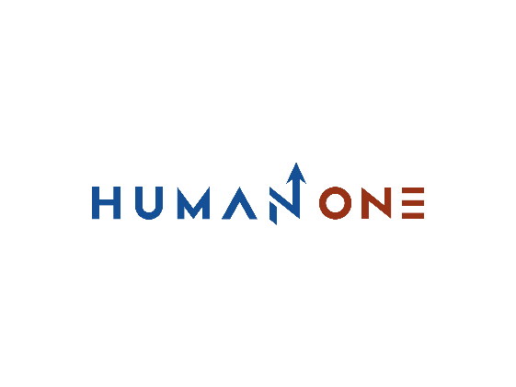

Services

Expertise

Technology Office

Who We Are

**EN**

**FR**

Get in touch

Company

# **Technology Office**



The HumanOne Technology Office is an IT advisory and excellence organization that can guide you through the uncertainty that comes with technological innovation. Our contribution to your journey starts with assessing your current development process and defining the business objectives you want to achieve with certain technology. After that, we come up with a solution and implementation strategy to overcome barriers to meaningful and effective change. The more complex your challenge, the more determined we are and the more intense the work we do.

Let’s Talk

We discover technological solutions for complex business challenges of self-sustainable enterprises whose main focus is quite far from innovation. Our technological guidance paves the way for established companies to retain and spread the love for already marketable products. We lead pioneering startups to leap ahead from early ideation to market success without spilling out a drop of their product spirit. Wherever digital transformation has already taken you, we guide the way out to the top-performing business you always meant to be.

**For whom Technology Office works the best**

**Pioneering Startups**

**Complex Product**

**Multi-level Enterprises**

**Multi-level Enterprises**

Your core business is massive, and you know it will only grow in the years ahead. You’re dealing with multiple stakeholders to maintain multiple products used by customers and within your company.

You’re great at analyzing business objectives. But what about technological innovation? Our mission is to translate your business goals into technological solutions. We’ll help you clearly understand the correlation between resources spent on IT and the impact on your core business. We’ll also advise you on the optimal tech stack or platform to streamline development. Technological guidance provided by the HumanOne Technology Office is your ticket to hassle-free IT transformation, which is overtaking the entrerprise sector.



**Pioneering Startups**

**Complex Product**

**Multi-level Enterprises**



You’ve achieved success, but with time, your product has gained complexity. Now you’re cautious about adding new features but still need to keep up with customer’s demands for innovation. While the chase for the market has cooled off, you need to ensure your product’s viability and security. You’re looking for a partner to keep your product sharp and running by overcoming bottlenecks that cause unstable performance, inefficient operations, and security breakdowns. You may benefit from our service reliability engineering, which guarantees your solution is available to a growing user base who will spread the world about its quality.

**Complex Product**

**Pioneering Startups**

**Complex Product**

**Multi-level Enterprises**

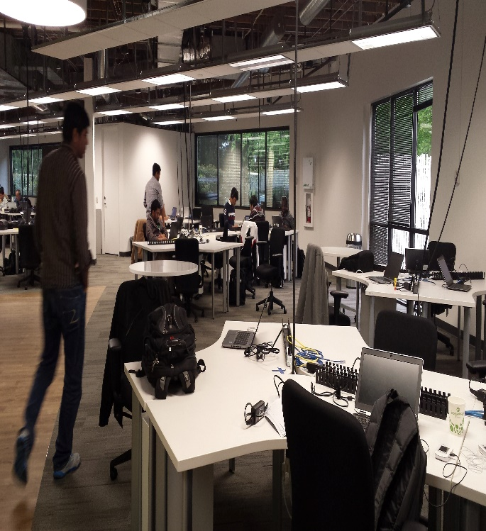

Your product idea is marvelous and has proven to solve user’ real-life struggles. But you’re still in a hit and run mode, looking for crumbs of certainty and chasing the elusive time to market. For you, our initial goal will be to assess how your present development process aligns with your desired pace and quality. Next, we’ll offer expertise to increase your development speed while maintaining the intended quality. Under these conditions, you’ll get the most out of our complete solution development guidance and DevOps advising for a fluent transition from brilliant idea to tangible feature. You’ll remain in control of your production at all times but without headaches.

**Pioneering Startups**

Boost your technology innovation

Get in touch

# **What you get from Technology Office**

**Data intelligence**

Draw additional value from your business assets by structuring and analyzing enriched data across your organization. Implement advanced technologies like big data, computer vision, and machine learning to eliminate routine tasks and make smarter decisions.

**IT advisory and DevOps**

Streamline your IT transformation with technology guidance, service reliability engineering, and a solution operation strategy. Embrace a DevOps culture within your IT organization by evaluating development resources and adopting optimal cloud platforms processes that are bogging down your operations

**Solution Engineering**

Build a technology solution for complex business problems from scratch with a set of efficient development services. Involve high-end professionals to assess your current solution, discover a contemporary technological vision, and cover full-cycle product development.

**Release Management**

Take advantage of expertise accumulated across our entire organization to reach tech-related objectives faster. Our Centers of Excellence unite top professionals within HumanOne to provide leadership and technological guidance at each stage of development.

**Cybersecurity**

Ensure your systems are secure from outside and inside threats by assessing corporate security and establishing a secure SDLC. Our cybersecurity consulting reinforces your defenses against known and emerging fraud, leaks, bugs, and cyberattacks.

**Experience design**

Starting with product discovery, move up to human-centered design embodied in a user-tested prototype interface. Our UI/UX design services are the cornerstone of an efficient customer retention strategy based on creating an engaging user experience.

**Technology Office along your journey**

03 **Production**

01 **vision**

02 **Engineering**

* Assess IT organization
* Evaluate technology choice
* Optimize processes
* Frame new solution
* Guide digital transformation
* Build solution architecture
* Design prototype
* Implement advanced technologies
* Adopt cloud and DevOps
* Design highly available system
* Automate infrastructure
* Deliver continuous updates
* Frame new solution